Subject : Object Oriented Programming Laboratory

//=====================================================================Lab Assignment 1 : Write a program to implement a class Complex which depicts the Complex Number data type. Implement the following operations: 1. Use of Constructor (incorporate default constructor which constructs the complex number in the form of 0+0i). 2. Overload binary operator + to add two complex numbers. 3. Overload binary operator * to multiply two complex numbers. 4. Overload operators << and >> to print and accept Complex Numbers.
//===================================================================

#include <iostream>
using namespace std;
class complex
{
public :
float real,img;

complex()
{
real=0;
img=0;

}
void get()
{
cout<<"enter real no";
cin>>real;
cout<<"enter img no";
cin>>img;
}
void display()
{
cout<<"Complex No: ";
cout<<real<<"+"<<img<<"i"<<endl;
}
complex operator +(complex);
complex operator *(complex);
friend ostream &operator <<(ostream &, complex &);
friend istream &operator >>(istream &, complex &);
};
complex complex ::operator +(complex obj)
{
complex temp;
temp.real=real+obj.real;
temp.img=img+obj.img;
return temp;
}
complex complex ::operator *(complex obj)
{
complex temp;
temp.real=real*obj.real-img*obj.img;
temp.img=real*obj.img+img*obj.real;
return temp;
}
ostream &operator <<(ostream &out, complex &obj)
{
out<<obj.real<<"+";
out<<obj.img<<"i"<<endl;
return out;
}
istream &operator >>(istream &in, complex &obj)
{ cout<<"Enter real no";
in>>obj.real;
cout<<"Enter img no"<<endl;
in>>obj.img;
return in;
}
int main() {

complex c1,c2,c3;
/* c1.get();
c1.display();
c2.get();
c2.display();
c3=c1*c2;
cout<<"multiplication is";
c3.display();*/
cout<<"Operator overloading << >>"<<endl;
cin>>c1;
cout<<c1;
return 0;
}

Lab Assignment 2: Write a program in C++ to implement a database of the student's information system containing the following information: Name, Roll number, Class, Division, Date of Birth, Blood group, Contact address, Telephone number, Driving license no. and other. Construct the database with appropriate member functions. Include constructor, default constructor, copy constructor, destructor, static member functions, friend class, this pointer, inline code and dynamic memory allocation operators-new and delete as well as exception handling.

#include <iostream.h>
using namespace std;
class student
{
public :
string name;
int rollno;
string bld_group;
string dob;
string clas;
string div;
long int tel;
static int counter;
student() // default constructor

{
rollno=0;
counter++;

}
student(int rollno) // parameterized
{
this->rollno=rollno;
counter++;
}
student(student &obj) //copy constructor
{
rollno=obj.rollno;
name=obj.name;
bld_group=obj.bld_group;
dob=obj.dob;
clas=obj.clas;
div=obj.div;
tel=obj.tel;
counter++;

}
~student() //destructor
{

cout<<" Deleting objects"<<endl;
counter--;
}

inline static void dis_counter()
{
cout<<"No of objects in the program : "<<counter<<endl;

}
void addData();
friend void display(student &obj);

};
void student::addData()
{
cout<<"Enter rollno"<<endl;
cin>>rollno;
cout<<"Enter name"<<endl;
cin>>name;
cout<<"Blgd group"<<endl;
cin>>bld_group;

/*
dob
clas
div
tel

*/

}
void display(student &obj)
{
cout<<"\t"<<obj.rollno;
cout<<"\t"<<obj.name;
cout<<"\t"<<obj.bld_group<<endl;

}
int student::counter=0; //static variable
int main()
{
student s1; // default
student s2(101);// parameterize
s2.addData();
student s3(s2);
//copy constru1ctor
cout<<"\tRollno\tName\tBloodgroup \n";
display(s1);
display(s2);
display(s3);
student::dis_counter();
int n,i; // no objects
student *s[50];
cout<<"Enter how many students you want in a class"<<endl;
cin>>n;
for(i=0;i<n;i++)
{
s[i]=new student();
}
for(i=0;i<n;i++)
{
s[i]->addData();
}
cout<<"\t Rollno \t Name \t Bloodgroup \n";
for(i=0;i<n;i++)
{
display(*s[i]);
}
student::dis_counter();

for(i=0;i<n;i++)
{
delete(s[i]);
}
student::dis_counter();

return 0;
}

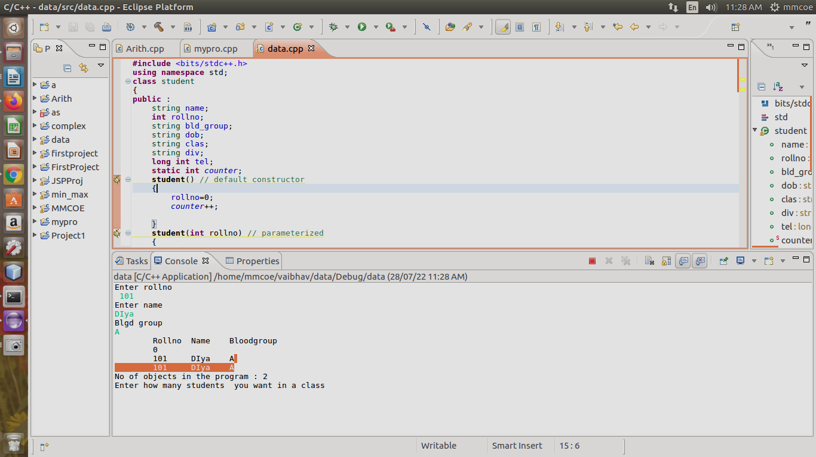

//===================================================================Lab Assignment 3 :Implement a class publication that contains the title (a string) and price (type float) of publications. Consider a publishing company which does marketing for book and audio cassette versions.From this class create two classes ( using Hierarchical inheritance): book class with page count (type int) and tape class with a playing time in minutes (type float). Write a program that constructs the book and tape class, permits user to enter data and displays the data members. In case, any exception is caught, replace all the data member values with zero values.
//===================================================================

#include <iostream>
#include<string>
using namespace std;
class publication
{
protected:
string title;
float price;

public:
publication()
{
title=" ";
price=0.0;

}
publication(string t,float p)
{
title=t;
price=p;

}
};

class book : public publication
{
int pagecount;
public:
book()
{
pagecount=0;

}
//After : base class constructor is called
book(string t,float p,int pc):publication(t,p)
{
pagecount=pc;
}

void display()
{
cout<<"title :"<<title<<endl;
cout<<"Price: "<<price<<endl;

cout<<"Pagecount :"<<pagecount<<endl;
}
};

class CD : public publication
{
float time;
public:
CD()
{
time=0.0;

}
//After : base class constructor is called
CD(string t,float p,float tim):publication(t,p)
{

time=tim;

}

void display()
{
cout<<"title :"<<title<<endl;
cout<<"Price: "<<price<<endl;

cout<<"time in minutes :"<<time<<endl;

}

};
int main()
{
cout<<endl<<"Book data"<<endl;
book b("C++",230,300);
b.display();
cout<<endl<<"CD Data"<<endl;
CD c("programming",100,120.5);
c.display();
return 0;
}

Lab Assignment 4: Write a C++ program that creates an output file, puts information to it, closes the file, opens it again as an input file and displays the information from the file. */

#include<iostream>
#include<fstream>
#include<cstring>
using namespace std;
int main()
{

fstream fobj;

fobj.open("File3.txt", ios::out);

char arr[100] ;
cout<<"Enter the data";
cin.getline(arr,100);

int length = strlen(arr);
fobj.write(arr,length);

fobj.close();

char line[100];
fobj.open("File3.txt", ios::in);

while(fobj)
{
fobj.getline(line,length);
cout<<line;
}
fobj.close();

return 0;
}

/* Lab Assignment 5 :
Write a program using the concept of function template for implementing selection sort that accepts, sorts and displays an integer array and a float array. */

#include<iostream>
using namespace std;
int n;
#define size 10
template<class T>
void sel(T A[size])
{
int i,j,min;
T temp;
for(i=0;i<n-1;i++)
{
min=i;
for(j=i+1;j<n;j++)
{
if(A[j]<A[min])
min=j;
}
temp=A[i];
A[i]=A[min];
A[min]=temp;
}
cout<<"\nSorted array:";
for(i=0;i<n;i++)
{
cout<<" "<<A[i];
}
}

int main()
{
int A[size];
float B[size];
int i;

cout<<"\nEnter total no of int elements:";
cin>>n;
cout<<"\nEnter int elements:";
for(i=0;i<n;i++)
{
cin>>A[i];
}
sel(A);

cout<<"\nEnter total no of float elements:";
cin>>n;
cout<<"\nEnter float elements:";
for(i=0;i<n;i++)
{
cin>>B[i];
}
sel(B);
}

/* Lab Assignment 7 : Write a program in C++ to use map associative containers. For Map containers, consider key as the names of states and the values as the populations of the states. When the program runs, the user is asked to type the name of a state. The program then searches in the map, using the state name as an index and returns the population of the state. */

#include<iostream>
#include<map>
#include<string>
using namespace std;
int main()
{
typedef map<string,int> mapType;
mapType populationMap;
populationMap.insert(pair<string, int>("Maharashtra", 7026357));
populationMap.insert(pair<string, int>("Rajasthan", 6578936));
populationMap.insert(pair<string, int>("Karanataka", 6678993));
populationMap.insert(pair<string, int>("Punjab", 5789032));
populationMap.insert(pair<string, int>("West Bengal", 6676291));
mapType::iterator iter;
cout<<"========Population of states in India==========\n";
cout<<"\n Size of populationMap"<<populationMap.size()<<"\n";
string state_name;
cout<<"\n Enter name of the state :";
cin>>state_name;
iter = populationMap.find(state_name);
if( iter!= populationMap.end() )
cout<<state_name<<" 's population is "
<<iter->second ;
else
cout<<"Key is not populationMap"<<"\n";
populationMap.clear();
}

